Oct 31, 2025
- Supply Chain Dataset
Raw Material | Properties | Typical Industrial Uses | Product Category (Assumed)
Sugarcane Fiber | High cellulose; biodegradable; fibrous | Packaging, paper alternatives, and sustainable plastics | Packaging Materials
Palm Oil Derivative | Fatty acid base; lubricating; surfactant properties | Lubricants, detergents, personal care, and industrial oils | Consumer & Home Care, Industrial Lubricants (Dầu nhớt công nghiệp)
Algae Oil | Renewable oil source; rich in lipids; eco-friendly | Biofuels, lubricants, specialty polymers | Automotive Solutions, Industrial Lubricants
Cassava Starch | Plant-based starch; strong film-forming | Bioplastics, adhesives, and packaging | Packaging Materials, Specialty Polymers
Corn Starch | Versatile polymer precursor | Bioplastics, surfactants, packaging, and household care | Consumer & Home Care, Packaging Materials
Wood Pulp | Cellulosic base; renewable; strong fiber | Packaging films, polymers, bio-based composites | Packaging Materials, Specialty Polymers
Soy Protein Extract | Biopolymer precursor; adhesive and binding | Specialty coatings, packaging resins, home care products | Specialty Polymers, Consumer & Home Care

- Task
  - Kwasi:
    - Look at sales revenue and R&D by product categories (do xlookup with the product master sheet)

Oct 27, 2025

Task for Next Meeting
- Share stand-out insights with proven visualization for your assigned datasets
- Statistics Summary for all datasets
Consider Questions: Where are the bottlenecks, inefficiencies, or risks in its
operations?
  - Kwasi Gyamfi Asante: Sales & R&D
  - Julie Bach: Supply Chain & Manufacturing
- Assumptions of how raw materials are used and joining datasets: Julie Bach

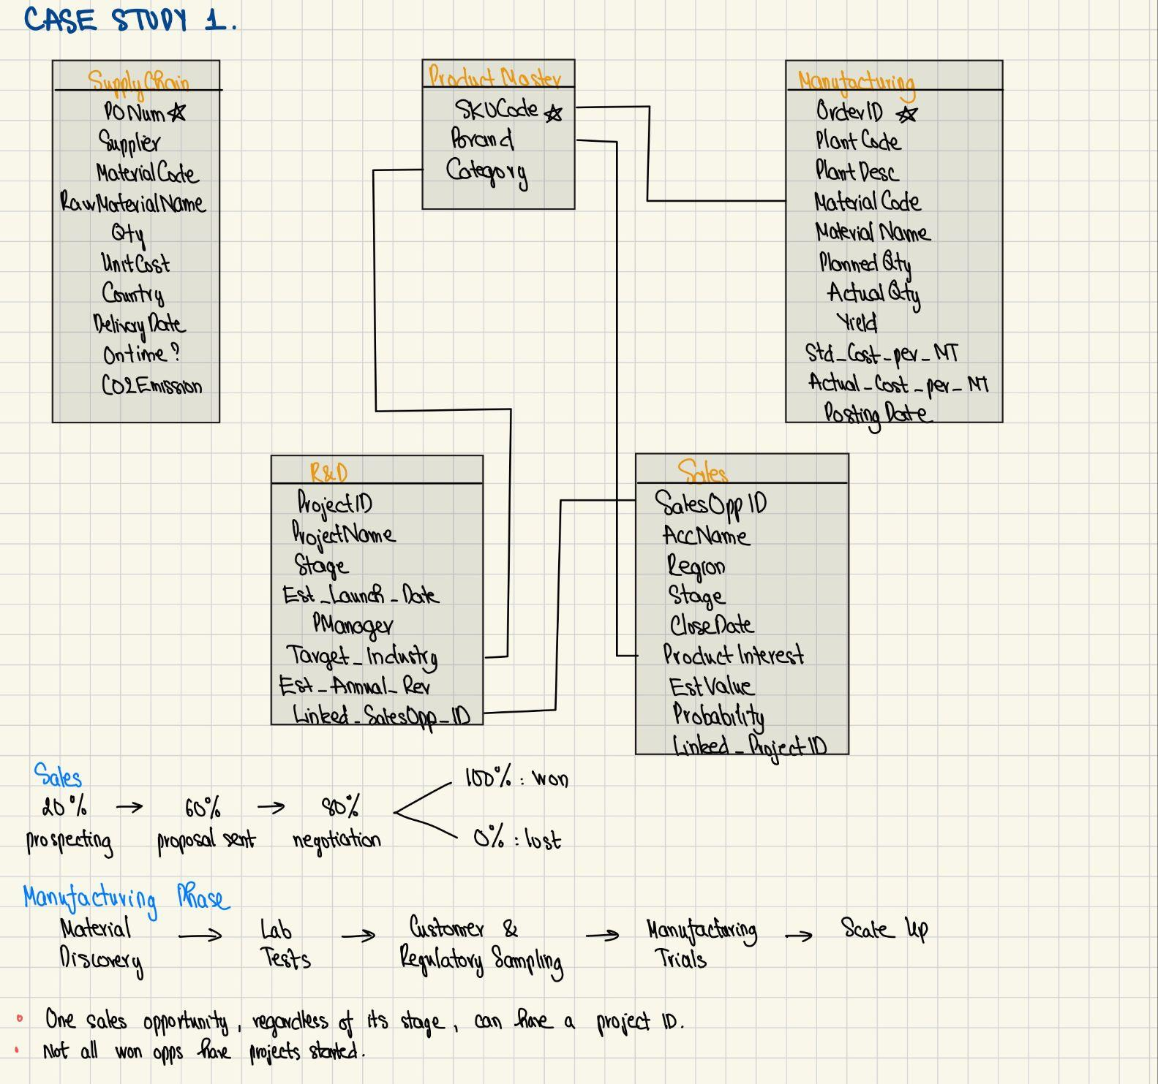 Business Questions
1. What does this business do, and how do its functions interact?
2. What insights can you derive about its current profitability, growth, and sustainability?
3. Where are the bottlenecks, inefficiencies, or risks in its operations?
4. What should the company do differently to increase profits while staying true to its mission?

Tasks
- Clarify with Professors tomorrow:
  - How is the Supply Chain dataset linked with the other (probably using Country)? Can we assume Raw Materials from Malaysia are manufactured in India? -> Make assumptions about what raw materials are used to manufacture specific material.
  - How does the supply chain and sales cycle look? Are projects only created based on customers’ opportunities?
  - How is the Close_Date field determined?
  - R&D shows estimated annual revenue. Some of the figures look high, especially for products that have not been launched yet.

Notes
- Possible Approach
  - Profit & Revenue split by regions, time period (e.g., quarterly, yearly)

- Sustainability
  - Using the CO2 Emission Field in the Supply Chain dataset
- Lost Sales Opportunities: Are we underperforming in any sales category?
- Deliverable
  - Tableau Dashboard
  - 7-slide presentation
- Deadline: 11/11

Oct 23, 2025
- 1st Meeting: Oct 27, 2025 at 5:30pm
- Tasks
  - Julie Bach explore ERP datasets
  - Kwasi Gyamfi Asante explore CRM datasets
- Goals
  - Insights from those datasets
  - Think about the business questions and potential solutions
  - Split tasks

